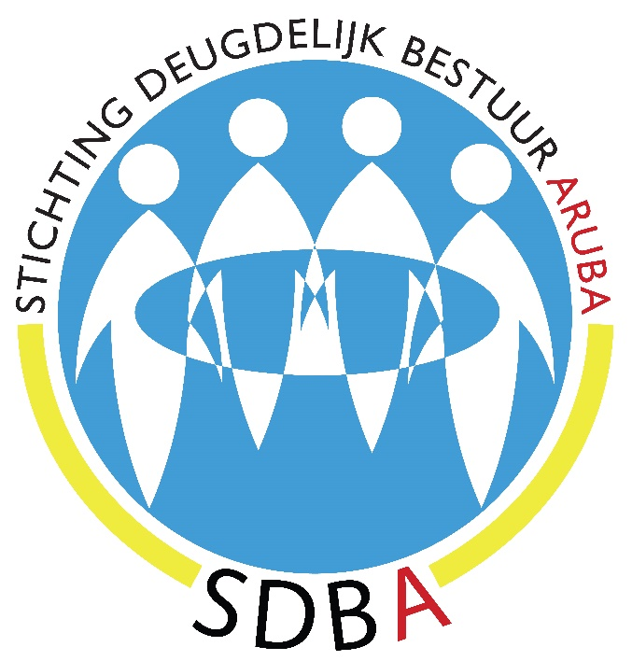

JAARREKENING 2016

Een compact financieel overzicht van SDBA
in het eerste jaar van haar bestaan.

www.deugdelijkbestuuraruba.org
www.bongobernashonaruba.org
Turibana 22, noord, ARUBA
Tel.: 297-586-5852
Cel.: 297-567-2976

FINANCIEEL OVERZICHT 2016

- PROFIT & LOSS JANUARY THROUGH DECEMBER 2016
# | Income | Afl. | # | Expenses | Afl.
43450 | Ind. & business contrib. | 6000,00 | 62140 | Legal expenses (notary) | 998,00
 |  |  | 62150 | Website set-up & service | 2.874,99
 |  |  | 65080 | Bank charges | 129,90
 |  |  | 68300 | Travel & meetings | 1.892,97
 |  |  |  | Total expense | 5.895,86
43400 | Direct public support | 6000,00 |  | Net income | 104,14

- BALANCE SHEET DECEMBER 31^{st, 2016}
# | Assets | Afl. | # | Liabilities & equity | Afl.
1010 | Account Aruba Bank | 104,14 | 32000 | Retained earnings | 104,14
 | Total Checking/savings | 104,14 |  | Total Equity | 104,14
 | Total current Assets | 104,14 |  | Total Liabilities & Equity | 104,14

